Case 13-US-GA-Etowah Mounds-Human Skull Effigy Pipe-Black Steatite-Mississippian-900 CE

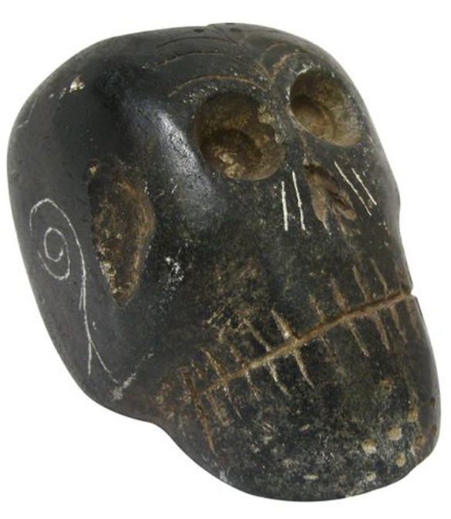

Etowah Mounds, GA, Black Steatite Skull Ceremonial Pipe. After <https://i.pinimg.com/originals/bd/9d/1a/bd9d1a9f4ac1475c9c8e85c740810540.jpg>

**Etowah Indian Mounds** ([9BR1](https://en.wikipedia.org/wiki/Smithsonian_trinomial)) are a 54-acre (220,000 m2) [archaeological site](https://en.wikipedia.org/wiki/Archaeological_site) in [Bartow County, Georgia](https://en.wikipedia.org/wiki/Bartow_County,_Georgia) south of [Cartersville](https://en.wikipedia.org/wiki/Cartersville,_Georgia), in the United States. Built and occupied in three phases, from 69–420AD, the prehistoric site is located on the north shore of the [Etowah River](https://en.wikipedia.org/wiki/Etowah_River). Etowah Indian Mounds It is the most intact [Mississippian culture](https://en.wikipedia.org/wiki/Mississippian_culture) site in the Southeastern United States.

Tykeon Wilkes used changes in ceramic styles across multiple sites in the Etowah River Valley to determine timelines for the region. The ceramics found at Etowah and other regional sites have been reconstructed and allow Etowah to be placed into the following sequences.[[6]](https://en.wikipedia.org/wiki/Etowah_Indian_Mounds#cite_note-KING2003-6) The town was occupied in three distinct [archaeological phases](https://en.wikipedia.org/wiki/Archaeological_phase): ca. 1000–1200 AD, ca. 1250–1375 AD, and ca. 1375–1550 AD. It was at its peak roughly from 1325–1375 AD.[[7]](https://en.wikipedia.org/wiki/Etowah_Indian_Mounds#cite_note-archaeology.org-7)

|  |  |  |  |  |
| --- | --- | --- | --- | --- |
| ***Period*** | ***Regional periods*** | ***Dates*** | ***Etowah Site Phases*** | **Ceramic markers** |
| Early Mississippian | [Etowah Phase](https://en.wikipedia.org/w/index.php?title=Etowah_Phase&action=edit&redlink=1) | 1000 – 1100 AD | Early Etowah | ladder base diamond predominant motif, shell tempering more common |
| 1100 – 1200 AD | Late Etowah | 2-bar diamond motif more prevalent, grit tempering more common, filfot cross, Etowah Incised and Hiwassee Island red on buff first appear |
| Middle Mississippian | [Savannah Phase](https://en.wikipedia.org/w/index.php?title=Savannah_Phase&action=edit&redlink=1) | 1200 – 1250 AD | Unoccupied | no inhabited sites along Etowah river valley |
| 1250 – 1325 AD | Early Wilbanks | coarse grit temper commonest, pottery thicker, bolder and with sloppier, complicated, stamped designs |
| 1325 – 1375 AD | Late Wilbanks | thinner pottery, more finely done stamping, minority vessel forms and designs appear, Rudder Comb Incised, Dallas Incised, Pisgah-like and Lake Jackson decorated |
| Late Mississippian | [Lamar Phase](https://en.wikipedia.org/w/index.php?title=Lamar_Phase&action=edit&redlink=1) | 1375 – 1425 AD | Stamp Creek | lack of Lamar Incised, rim modifications appear, |
| 1425 – 1475 AD | Mayes(provisional) | wider rims than previous phase, boldly executed 3-line incised designs |
| 1475 – 1550 AD | Brewster | narrower incised lines, stamping sloppy with most motifs no longer distinguishable, rectilinear designs common, Brewster and Barnett are temporally equivalent and are more of a geographic distinction in the valley |
| 1500 – 1625 AD | Barnett | higher percentage of shell tempering than Brewster with types such as Dallas Plain, Dallas Incised and Dallas Filleted |